Microcomputer Design – Guidelines Version 1.4

General Advice
- Reference the textbook for any question you might have. I can’t stress this enough. This hardware has been around for 20 years and the textbook thoroughly documents its operation.
- If you can’t find it in the textbook, look it up online! Google is a CE’s best friend.
- Pick out the components you want to use during the first week, even if all the component presentations aren't finished.
- Use a CPLD, regardless of your knowledge of Verilog or VHDL. The code for this project is really simple.
- Supervisor chips are overrated. I wired the switch straight into the HALT* and RESET* lines and it worked.
- Generate a 100ms power-on-reset pulse using your CPLD. To do this, make sure HALT and RESET as well as the CPU CLK are connected to the CPLD.
- Order all your components from one place (if possible), and don't forget little stuff like caps or test points.
- Many manufacturers send free samples. Check on this and get the free stuff ordered within the first 2 weeks.
- Have a rough schematic by the second week.
- If you miss a deadline, don’t fret. Just learn your lesson, don’t procrastinate any further and stay focused on the project. It is very possible to make the presentation deadline after missing a few of them along the way. That being said, it definitely takes hard work, determination and complete focus.
- Soldering materials can be found in the lab
- A heat gun is useful.
- Order the same components as classmates so students can swap components for testing. Before testing with someone's components, make sure the correct voltage is being delivered so you don't fry components that aren't yours.

Wire the power lines in a bus configuration; strongly avoid daisy chaining.
However, this is not a hard and fast rule. Daisy chaining most things actually seems to work fine.
Here is a picture of a by-pass capacitor layout that worked fine:

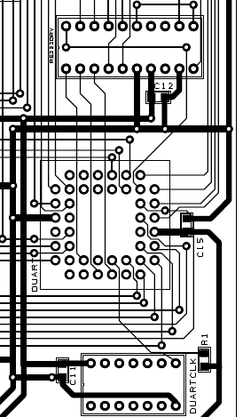

Figure 1 - Example of bypass capacitor PCB layout that worked fine

A power LED for each voltage source is advisable.
Again, the bus configuration applies here. Noise on daisy chains is additive; bus configurations are less vulnerable. Matched line lengths for multiple clock runs may keep things better synchronized for very high frequencies. (Transmission line effects aren’t the only concern here, but also skew.) To avoid problems (for this class) keep clock frequencies to a minimum.
Clocks and Oscillators should be as close as possible to their client chips. Crystal oscillators must have capacitors very near by, and the whole circuit must be very near the uP. Otherwise the crystal might not resonate.

Something I would make sure the students know is that despite the address numbering in the RAM and ROM data sheets A1 will be the first one to run into what the datasheets call A0. This offset affects all address lines to the Ram/Rom chips. Also run the CE/CS lines for each RAM and rom chip separate to the CPLD.

It is also advisable to have 5V power and ground lines running all the way around the border of the PCB. This strategy inherently eliminates daisy chaining and produces a very clean-looking board.

Component Selection
- Component guidelines
- Stick with recommended parts that have been used before. It’s better to have a fail-safe design than to try to be “unique” and run into unexpected problems that nobody else has encountered before.
- Don’t set out with impossible goals. Aim for the bare minimum, and if you still have time afterwards to go above and beyond the scope of the project, go for it! Chances are, you won’t.
- Choose parts that have clear PCB footprints in the datasheet.
- Read datasheets closely and watch out for typos. They might have info you need. e.g. I was looking and looking for voltage ratings for on/off switch and it said see I-23 for additional ratings. It should have been J-23 (had all info I needed and had searched a LONG time for.)
- Get ZIF sockets for the ROM chips. Worth. Every. Penny.
- It's not any better to get a single RAM chip.
- Avoid SMD if at all possible – DIP and PLCC are much, much easier to troubleshoot and solder.
- Using sockets for every component is strongly recommended.
  - 3M sockets are high-quality and have trustworthy datasheets.
- For test pins should stick up, 1cm fine, 0.5cm is too short.
- Clock: needs to be slower or same as CPU. 8MHZ plenty fast for CPU and CPLD (for 10MHZ CPU) do not go over 14MHZ.
- CPLD: bigger is better, at least as fast as clock.
- Resistor: 1k (510 ohm recommended) needed for pullup/pulldown resistors for unused CPU inputs. However, connecting unneeded inputs to a CPLD is even better.
- Resistor not needed for output pins and power pins on CPU or CPLD
- Capacitor: two 10uF needed for power supply input and output.
- Capacitor: either 1uF or 0.1 uF needed for bypass capacitor to chips (CPU, CPLD, ROM, DUART,RAM and CLOCK). One input with power pin on chip and other input should be GND.
- Reset circuit is needed for CPU but not necessary for DUART
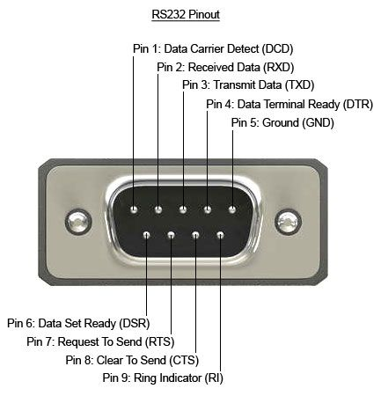
- Male Serial connection:

- Common component selection and wiring mistakes
- Push button wired incorrectly. The halt and reset lines should remain high until depressed.
  - This can also be remedied by running HALT and RESET through the CPLD with a common output to the CPU and DUART.
- Square chips like some clocks rotated 180º or flipped.
- Check to make sure all solder points make a solid connection to the board and socket.
  - Use the continuity tester on a standard multimeter for verification.
- Test pin header pin hole spacing was too small
- PLCC Socket numbering issue – some data sheets are not correct!!
  - Pin 1 on PLCC chips and sockets most often appear on the middle contact on the top row. Make no assumptions about the pin placement, find an accurate data sheet.
  - Don't guess at the PLCC numbering pattern. The following datasheet shows standard PLCC socket pin numbering for 84, 68, and 44 pin sockets:
- Everything should work on example parts list from Dr. Kim, but you'll still want to go through it.
- Probably use Normal/Red/Green LEDs and 330 Ohm resisters, which you should be able to get all from 1 company, e.g. Digikey or Mouser
- If in doubt – ask your lab assistant!!

Example of datasheet with upside-down PLCC (pin layout still correct):

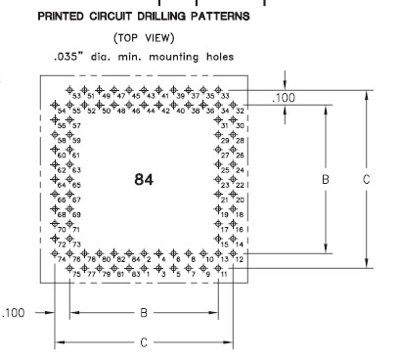

Example from 3M PLCC datasheet with correct pinout and orientation:
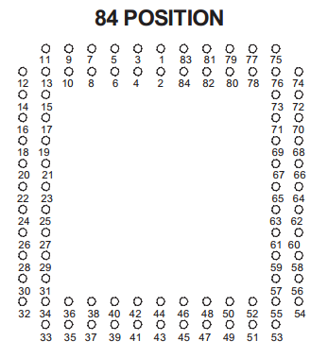

Schematic Design

Schematic Design
- Schematic guidelines
- READ YOUR DATASHEETS
- Address, Data, Ground, and Vcc should be self explanatory, so run them directly between the devices.
- Everything else should be run separately (i.e., don't even wire the 2 ROM or RAM CS/CE lines together) into the CPLD. This will give you maximum flexibility should you need to change the board later. Some exceptions to this are a few pins on the DUART and MPU that you won't use, as well as some pins on the driver chip that merely need to be connected to other pins on itself.
- You need at least a couple of address lines run into the CPLD to serve as the address decode lines (ROM = 00000, RAM = 10000, DUART = 20000, etc). If you want to use interrupts for input, then you'll need to run more address lines in. Check your MPU datasheet.
- Your CPLD does not need the data bus. Save some pins.
- Don't forget to run the CLK into the CPLD.
- I didn't find test pins for the data bus very helpful. Do address bus, function code, address and data strobes, DTACK* and BERR*, and the like instead. Many of these can be routed via CPLD lines.
- If you are unsure about any connection, route it through the CPLD. A quick software fix is far easier than a hardware reroute. Use EVERY pin on your CPLD…it will save your life down the road.
- Understand how you will implement your address decoding, then connect and name your CPLD inputs and outputs correspondingly.
- Triple-check every single pin on your schematic with your datasheets and the textbook. Remember: 10 minutes now will save you 10 hours down the road. Be THOROUGH.

- Common schematic design mistakes
- When comparing or checking the address bus you must also insure that AS is low.
  - (i.e. IF Address = ‘000’ AND AS_CPU = ‘0’.)
- Make sure any pins you routed to the CPLD to set as high or low are implemented in the VHDL code. Do not forget you routed them there and leave them floating or in high impendence. (i.e. the interrupt controls)
- Remember to set your logic for the ram chips so that the processor cannot accidentally write to it.
- Always implement LDS and UDS for the ram chips.

PCB Design
- READ YOUR DATASHEETS
- Study each of the component pinouts, practice, and plan your layout before you start. This will simplify your routing and make your final board look cleaner, smaller and more professional.
- CPLD and MPU probably should be in the middle of the board.
- Get the PLCC socket patterns right. Make no assumptions about the pin placement, find an accurate data sheet. The following datasheet shows standard PLCC socket pin numbering for 84, 68, and 44 pin sockets:
- Also be sure to check through-hole pin sizes. Having to mill out larger holes or double-socket is a huge pain. Be especially wary of ZIF sockets and TO parts (such as voltage regulators).
- Print out your PCB layout and make sure parts are oriented correctly, especially your DSUB!
- Order by 1st week in February.
- Do only a 2 layer board.
- Recommend fitting in 60 square inches.(Max.10X6 inch. Or 7X7)

Soldering Guidelines
- Don't stress about flux removal. Can try to clean off a bit with rubbing alcohol but don't worry if don't get all of it.
- Inspect any shady-looking connections with a continuity tester.

Software Tips:
- Write the software and test it in simulation immediately after sending the PCB off to be fabricated.
- Note that the Easy68K Simulator does not do word and byte moves correctly. It clears all the upper bits of the register that should not be affected.
- Use input/output routines from the monitor program in the book. They may require some slight modifications.
- S-Records are not hard if your hardware can do byte writes to RAM (this is were the not connecting the CS/CE lines of RAM together comes in handy).

Common Mistakes
- Assigned Stack pointer outside the bounds of the space in RAM.
- Miscalculated the values of the addresses for each chip. ‘001’ on A23-21 corresponds to 200000 and ‘010’ would be 400000. Rom should always be ‘000’.
- When running monitor program on hardware I need to clear the upper unused portions of data registers in order to make comparisons work.
- Forgetting to back up A0 on stack in hardware-only code sections that modified it.
- Saving/Restoring registers to/from the stack when they are meant to be used as outputs.
- Incorrectly initializing DUART registers – see datasheet as well as example code in textbook.
- Triple-input problem on DUART - Workaround: Reset DUART each time it is used to send/receive.
- BEWARE: Sign extending of address made A23 go HIGH, therefore in VHDL need to ignore A23 in order to make DUART be selected.

